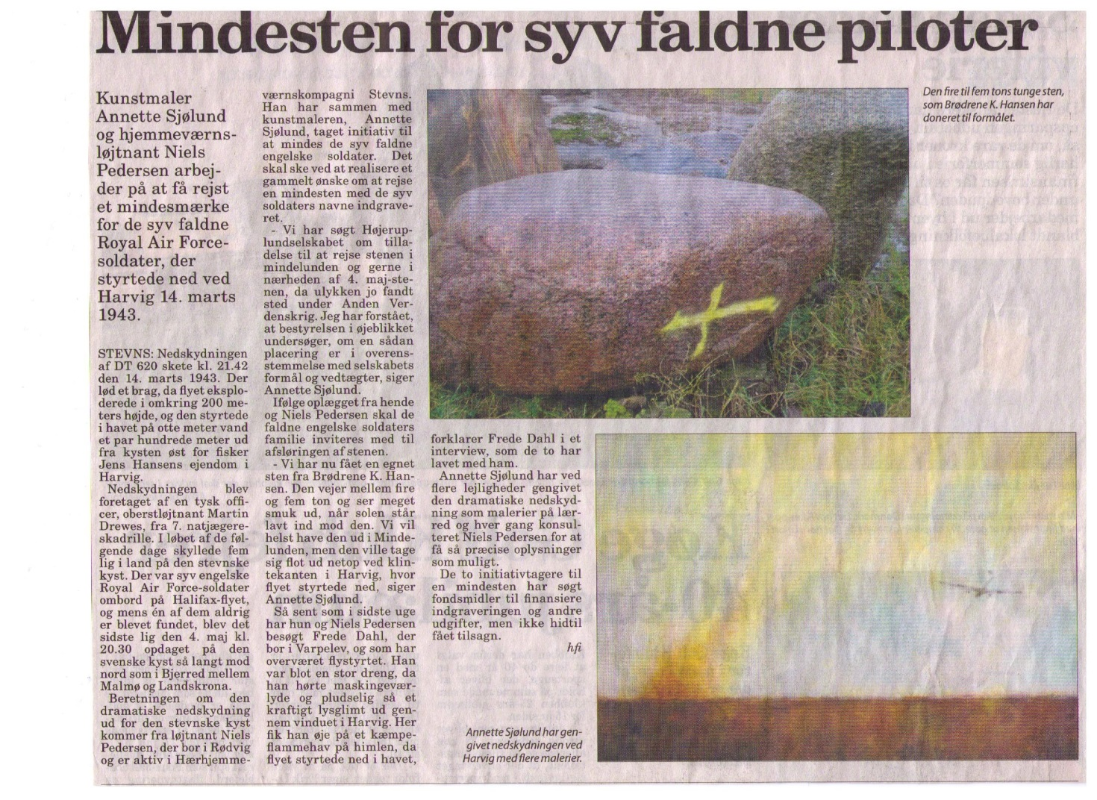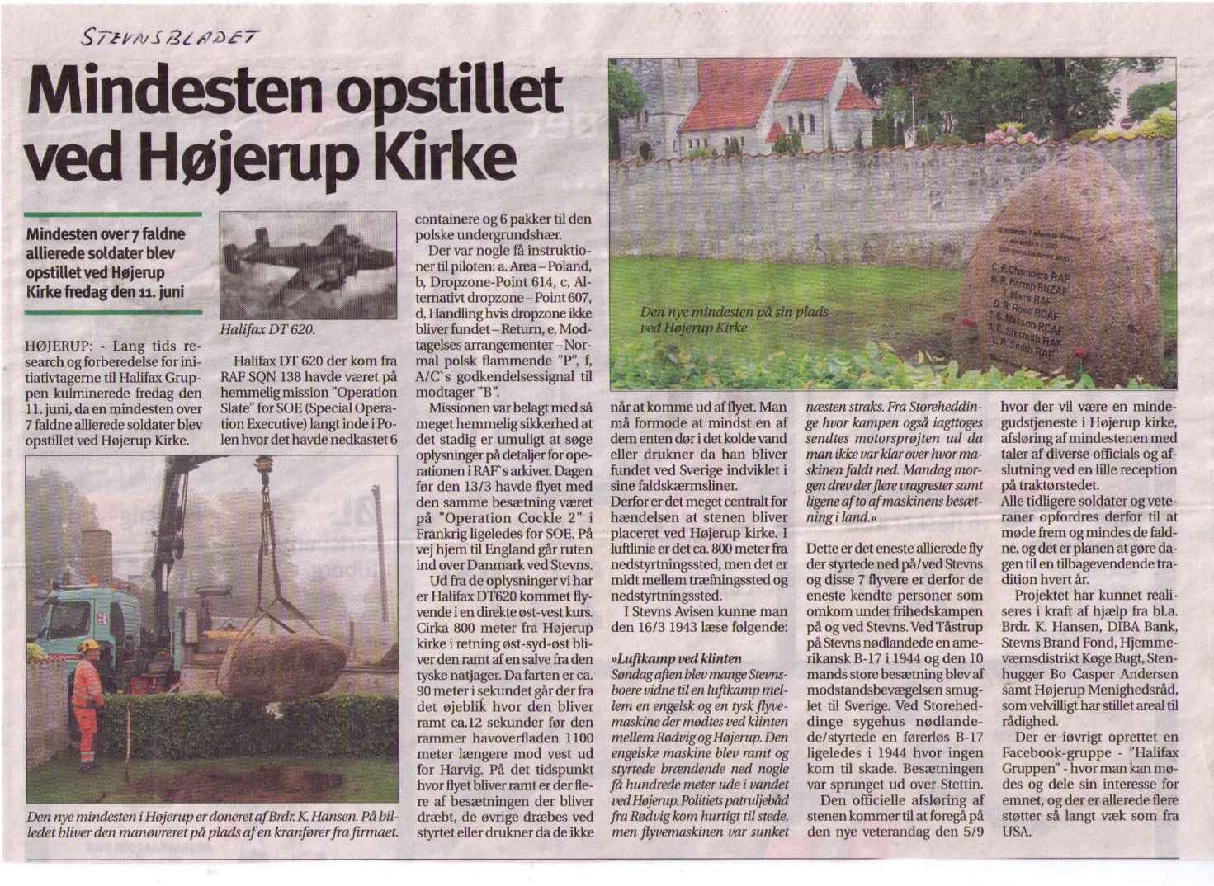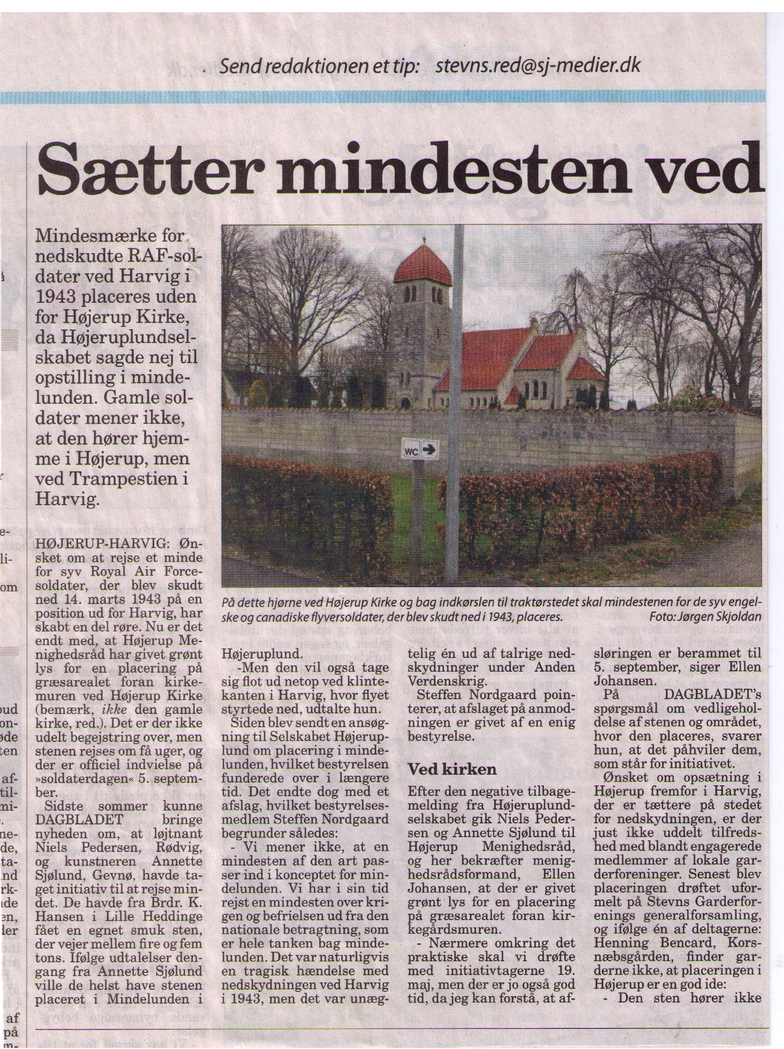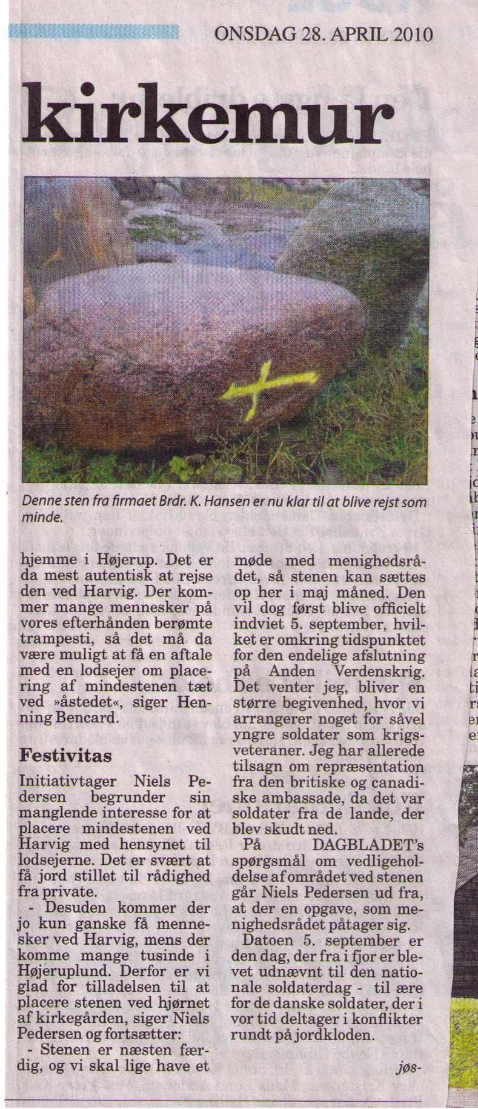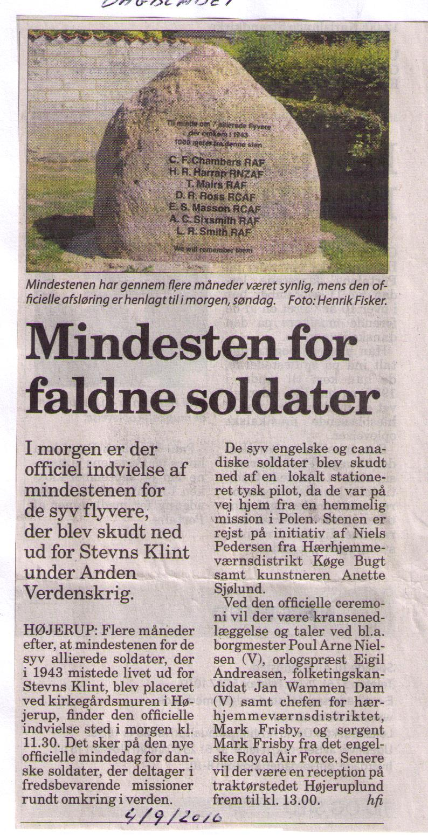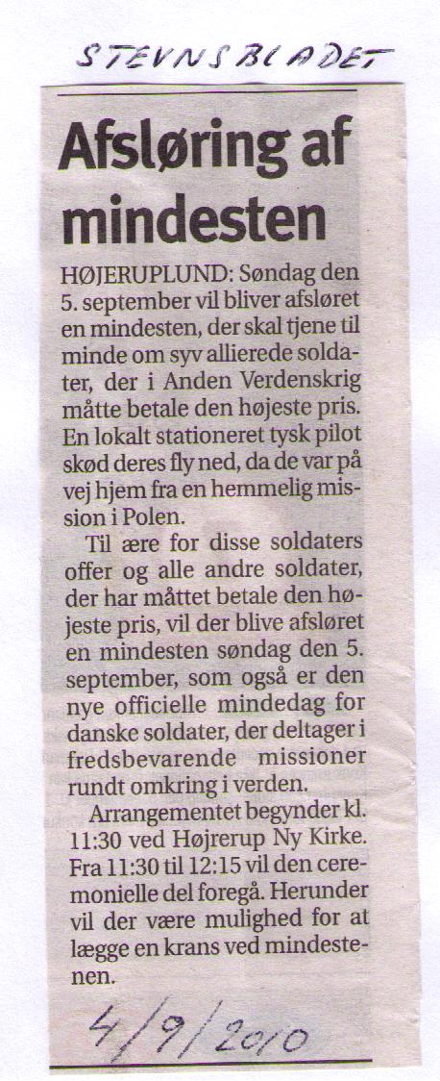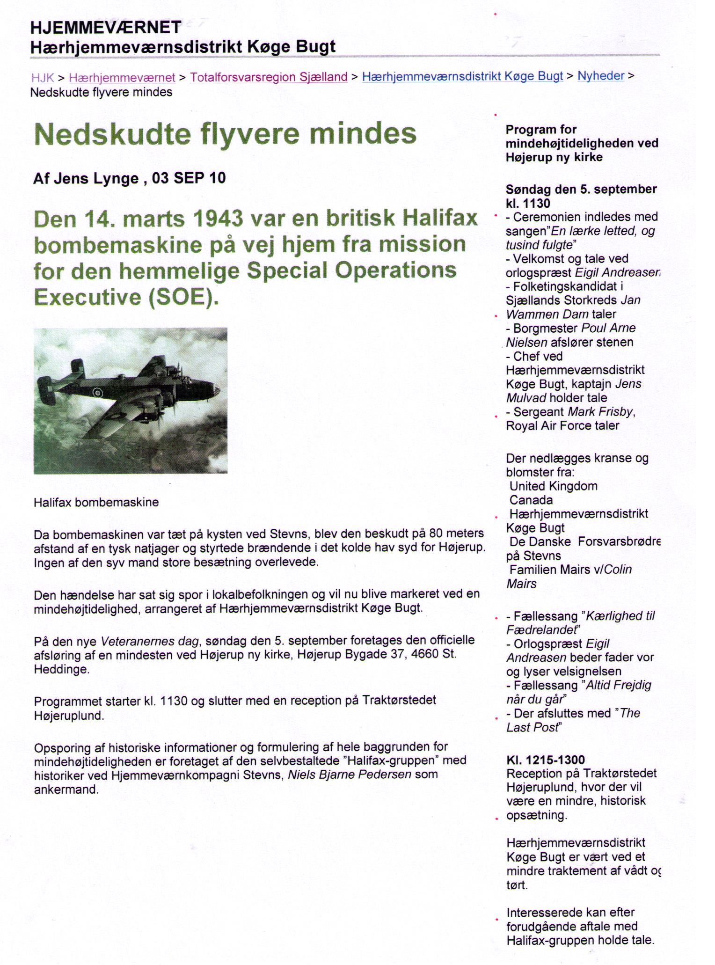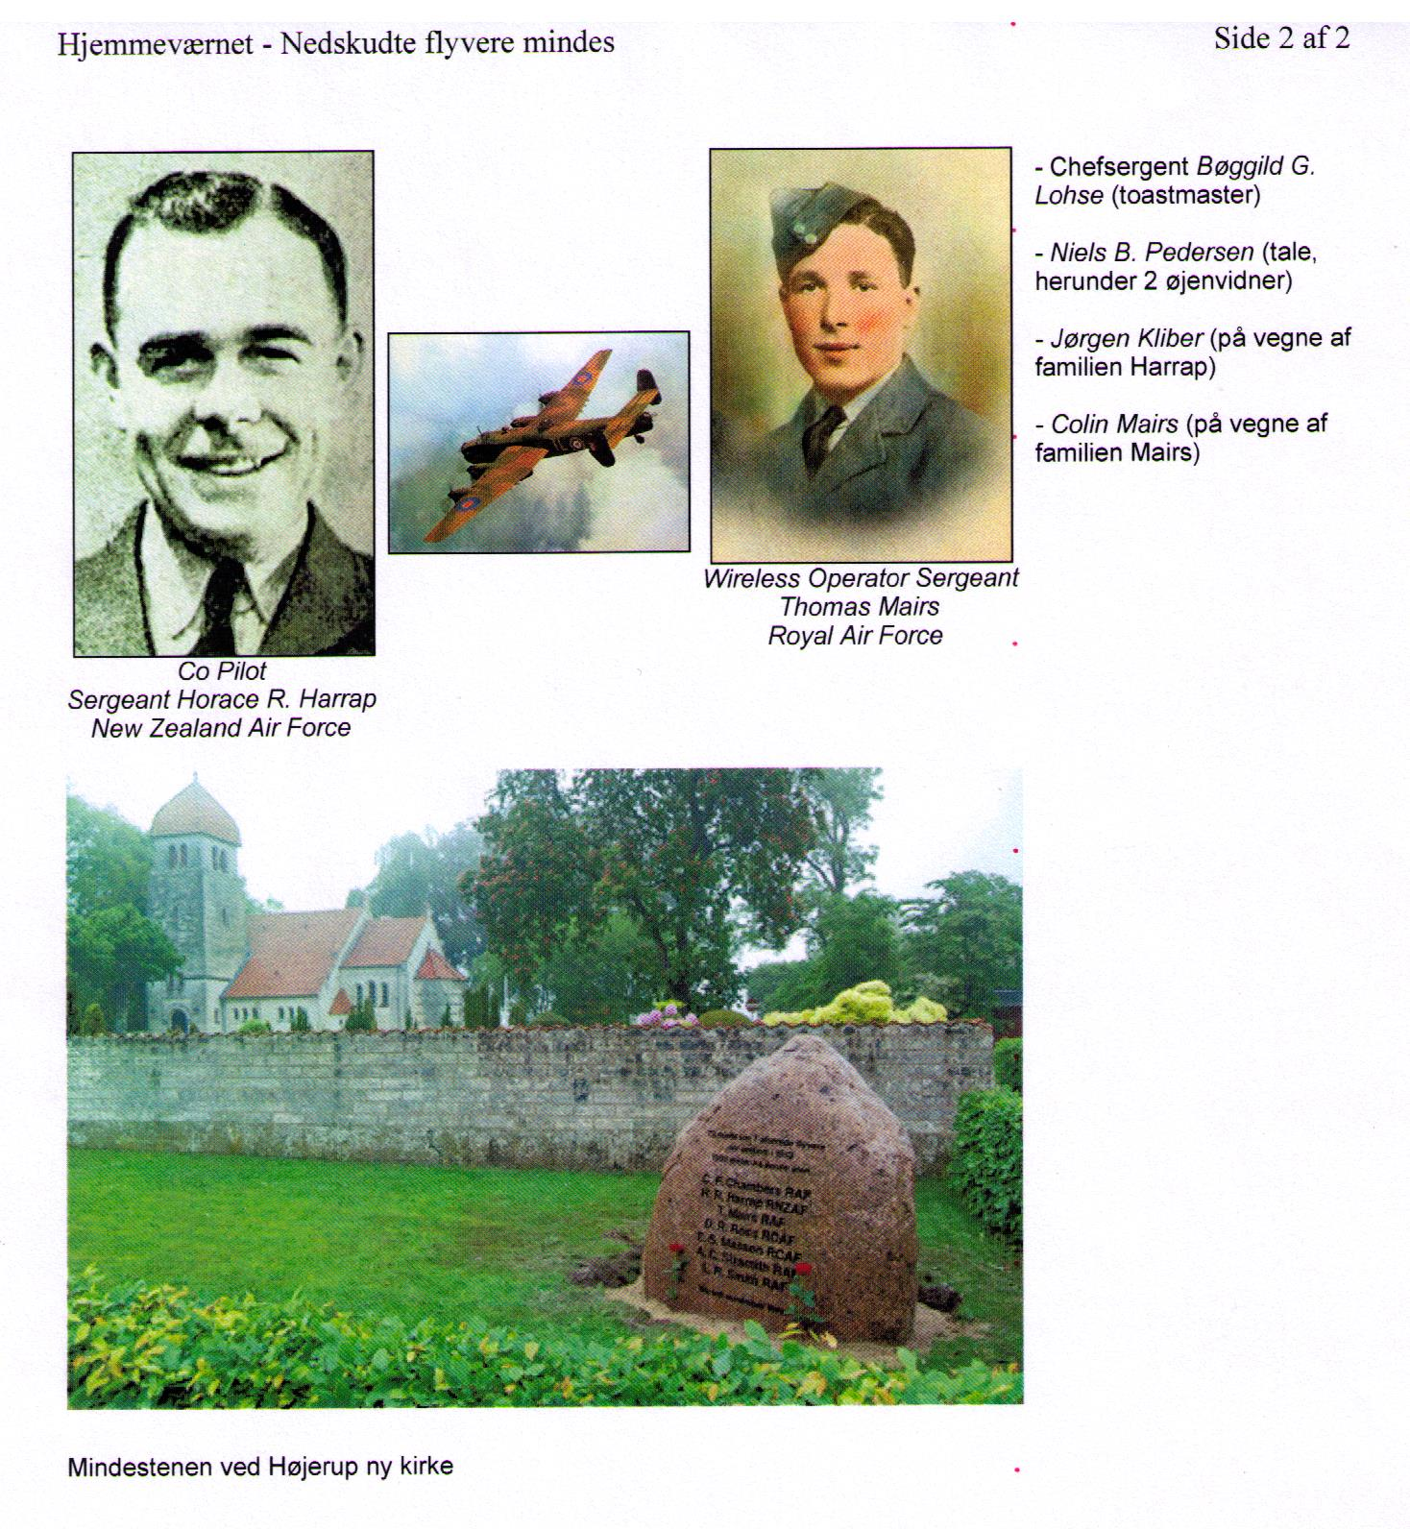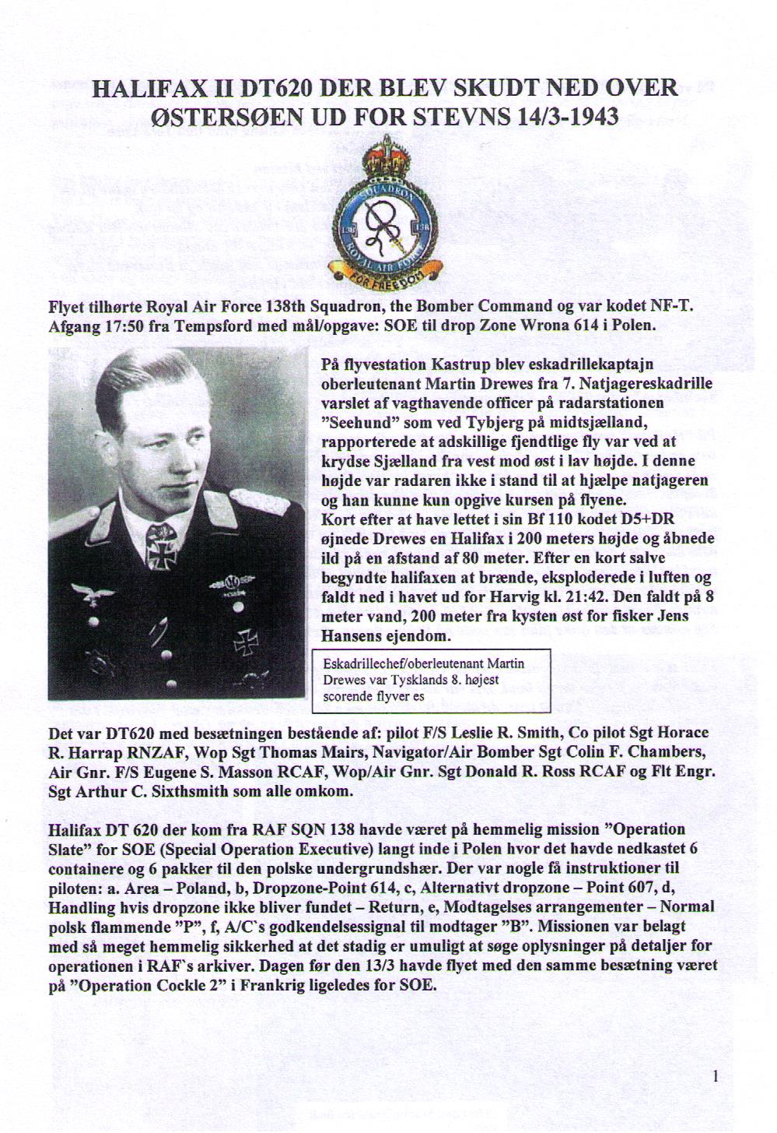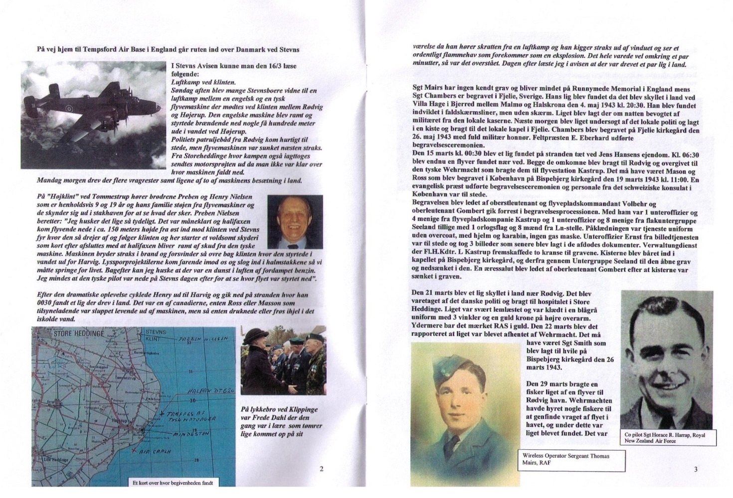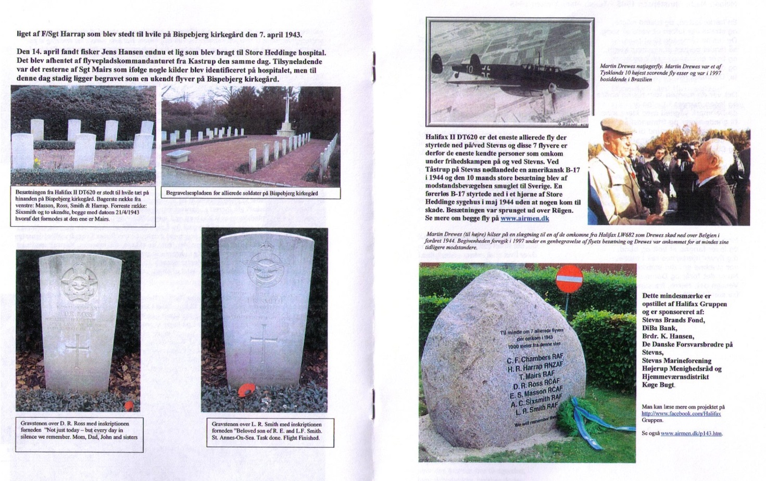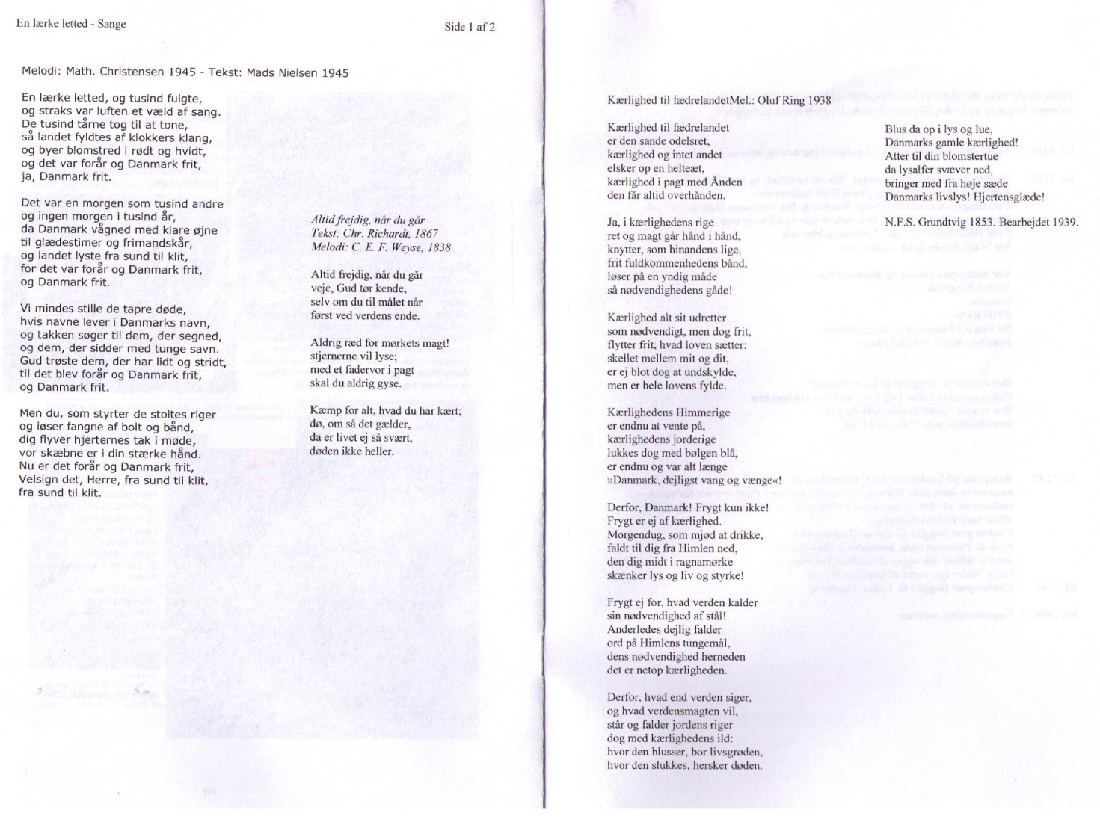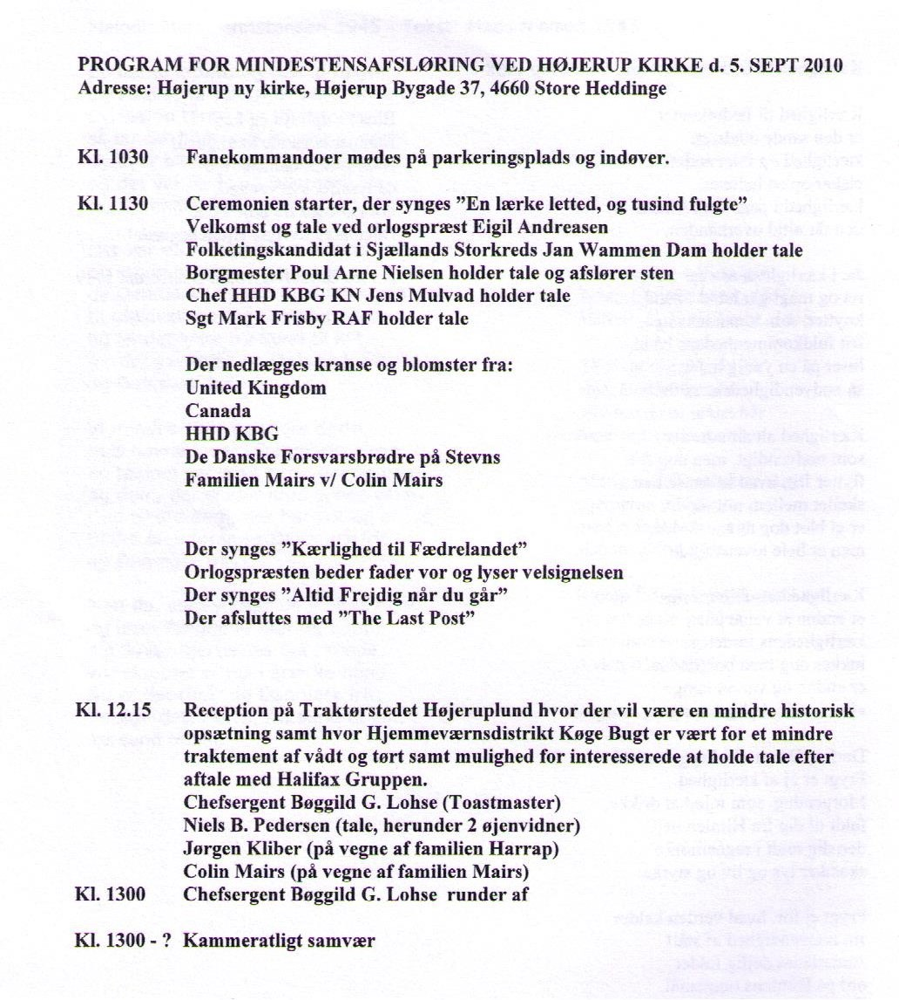
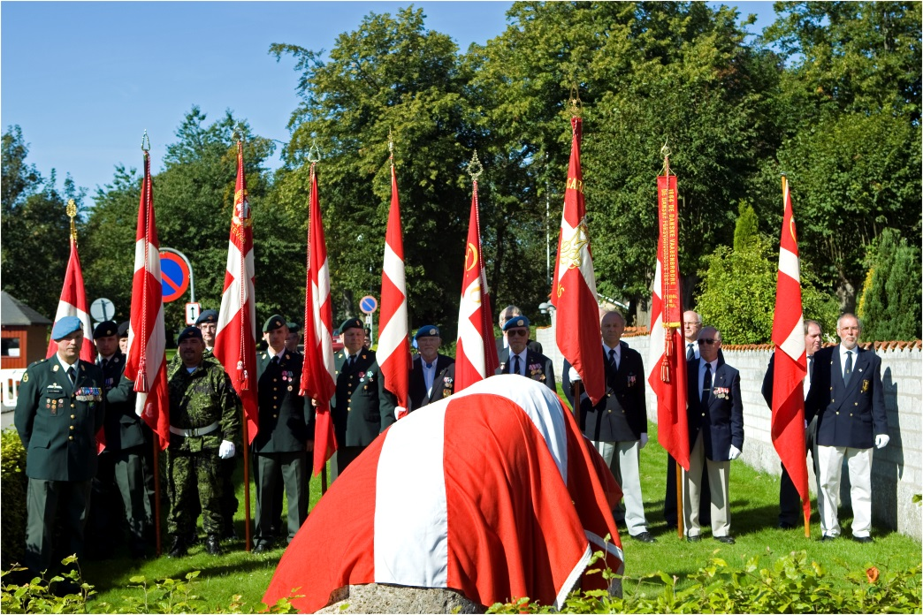
Beautiful and touching ceremony in Højerup
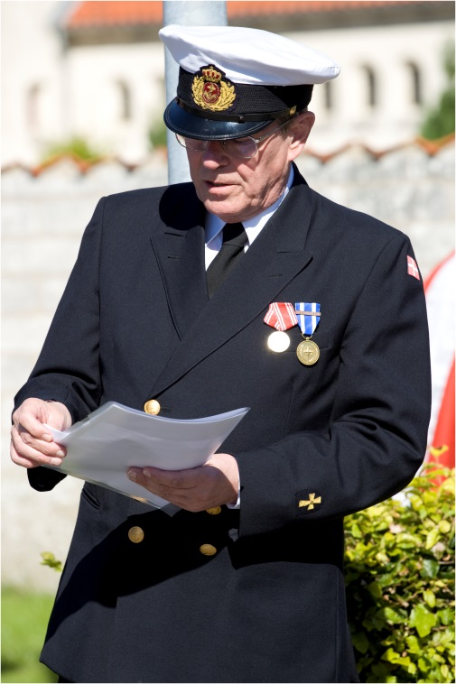
Sunday on the 5th September was, the culmination of long research and planning for the detection of memorial stones at Højerup Church on Stevns.

Right: in lead of the 9 colour guards represented from Army, Navy & Air Force & Soldiers Associations were #1831 Niels B. Pedersen

It is the story of the crew, seven Allied airmen in Halifax DT 620 that was shot down off the coast Stevns 14th March 1943 which had set # 1831 Niels B. Pedersen Rødvig started to investigate what really happened - and to coordinate work in order to develop a lasting memorial to the seven airmen from Canada, England and New Zealand.
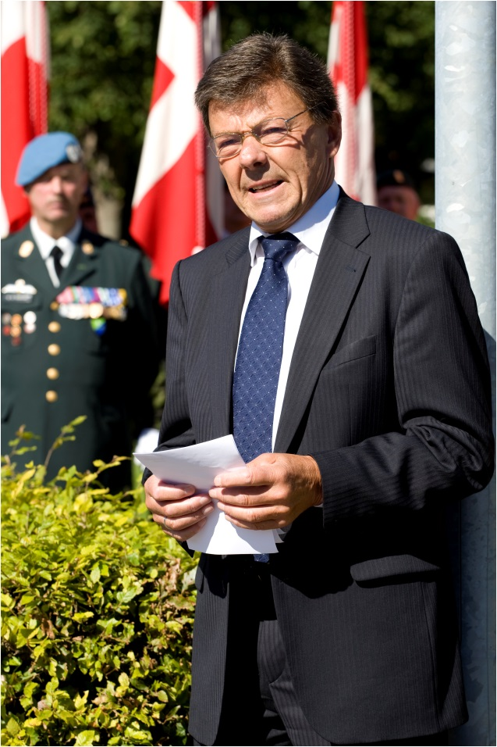
Right: the navy chaplain Eigil Andreasen in lead of the ceremony

Left: Poul Arne Nielsen, the mayor of the Stevns Community, speaking

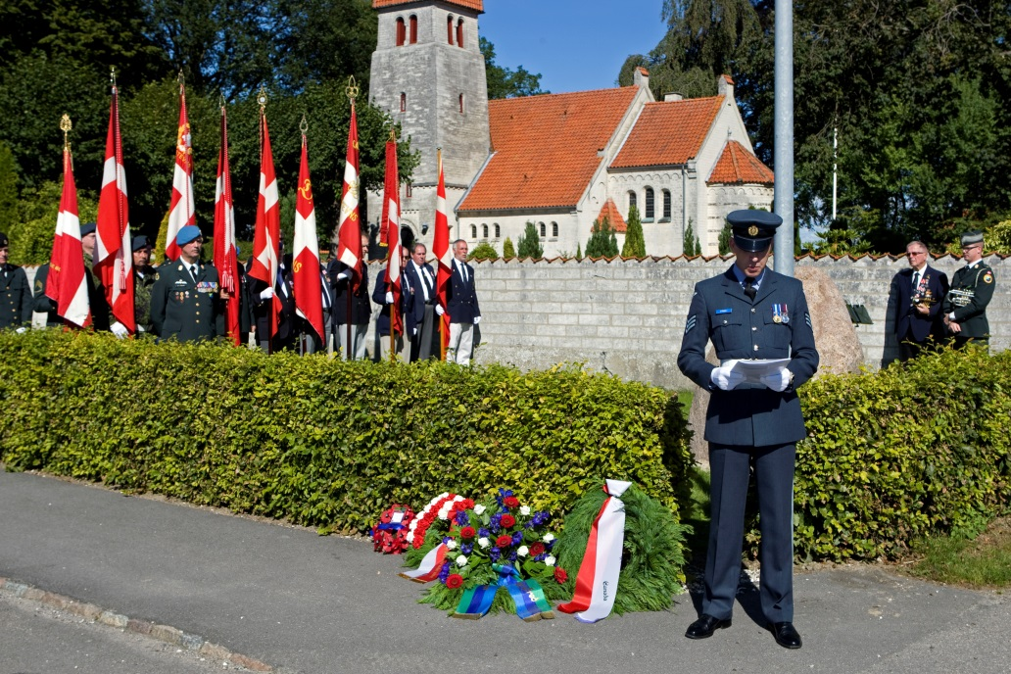
Well over a 100 people attended and witnessed a very beautiful unveiling ceremony, where no fewer than nine colour Guards were present - and where speeches, music and songs, wreaths and reception afterwards was memorable day for the many attendees.

The representative for the British Embassy Sgt Mark Frisby Royal Air Force are speaking.

Most profound was the report from a relative, a nephew of one of the British pilots who expressed great gratitude that his uncle and his colleagues from the crashed aircraft now have established a memorial. Not least his greeting from a 89 year old British woman who was engaged to Thomas Mair and which would have been married to him three months after the accident, was moving. This woman, Gladys from Warrington in England - has now been fulfilled a long cherished desire. On behalf of the family Harrap in New Zealand spoke Jorgen Kliber - and expressed the same gratitude for the initiative.

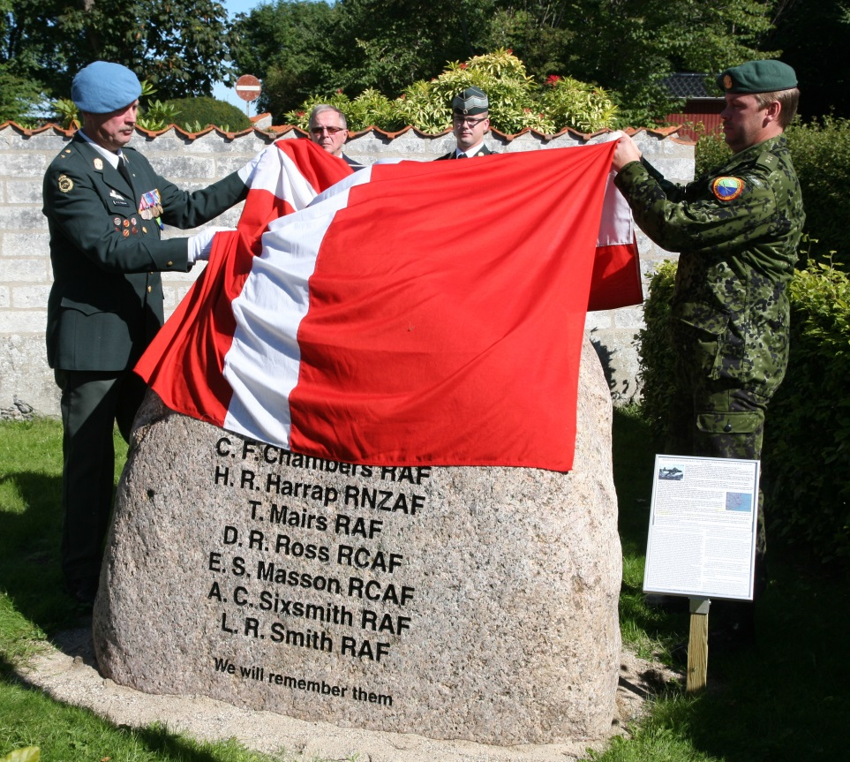
In addition, spoke Navy Chaplain Eigil Andreasen, parliamentary candidate Jan Wammen Dam, Mayor Poul Arne Nielsen, Commander of HHD KBG Jens Mulvad and Mark Frisby from Royal Air Force.

Niels B. Pedersen & Jens Mulvad unveil the memorial

Kim Girtel presented the wreath on behalf of the Canadian Embassy

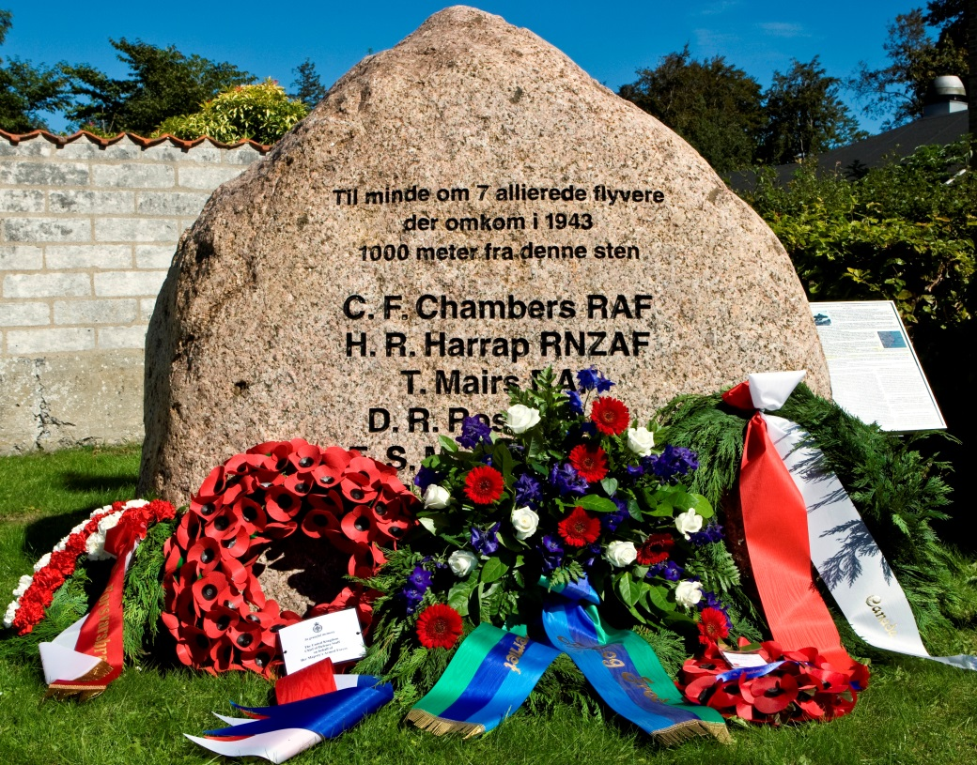
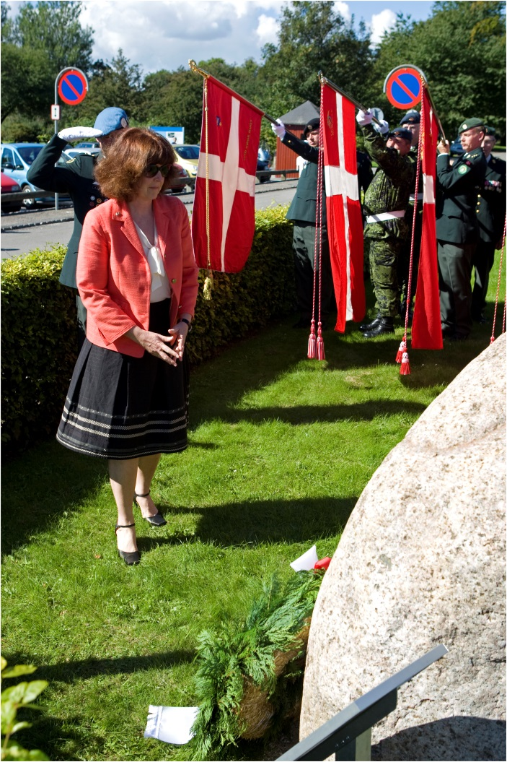
Common to these talks was respect for fighting for what you believe in the fight for freedom and democracy to life as the highest performance - and parallels drawn to 2010, when the fighting continues and unfortunately still requires sacrifice.
RAF Sergeant Mark Frisby presented the first wreath on behalf of the British Embassy, Counsellor Kim Girtel on behalf of the Canadian embassy, Captain Jens Mulvad on behalf of HHD KBG, Arvid Jorgensen on behalf of the Danish Defence Brothers and finally Colin Mairs on behalf of the family Mairs.
During the reception at the nearby restaurant talked Niels Pedersen on his great personal commitment and the personal pleasure it was to make contact with descendants, both in England and New Zealand - and about being able to speak to eyewitnesses, Frede Dahl and Preben Nielsen, who in childhood and adolescence witnessed the fierce air battle off Harvig up close. Niels Pedersen ended the speech with the words "We will remember them" - which is also a part of the text on the beautiful stone which now stands in front of the church wall at Højerup Church.
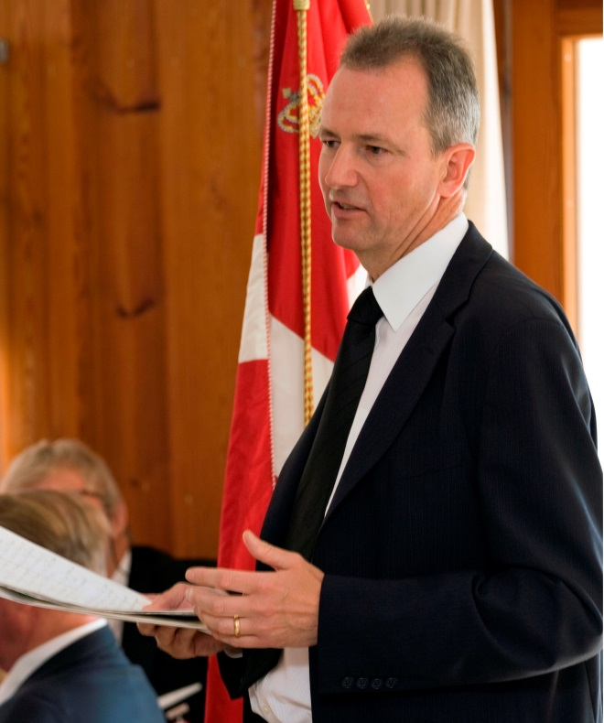

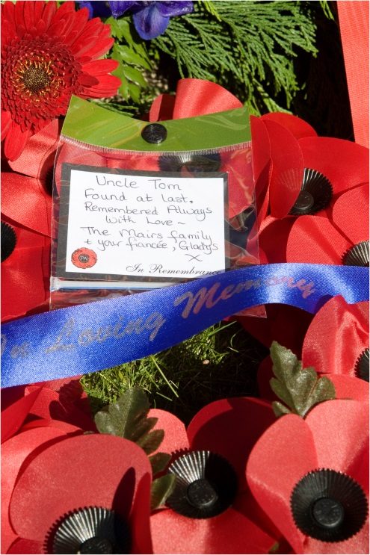
Right: Colin Mairs a nephew of airman Thomas Mairs expressed great gratitude in his speech and left the poppy wreath from the Family Mairs

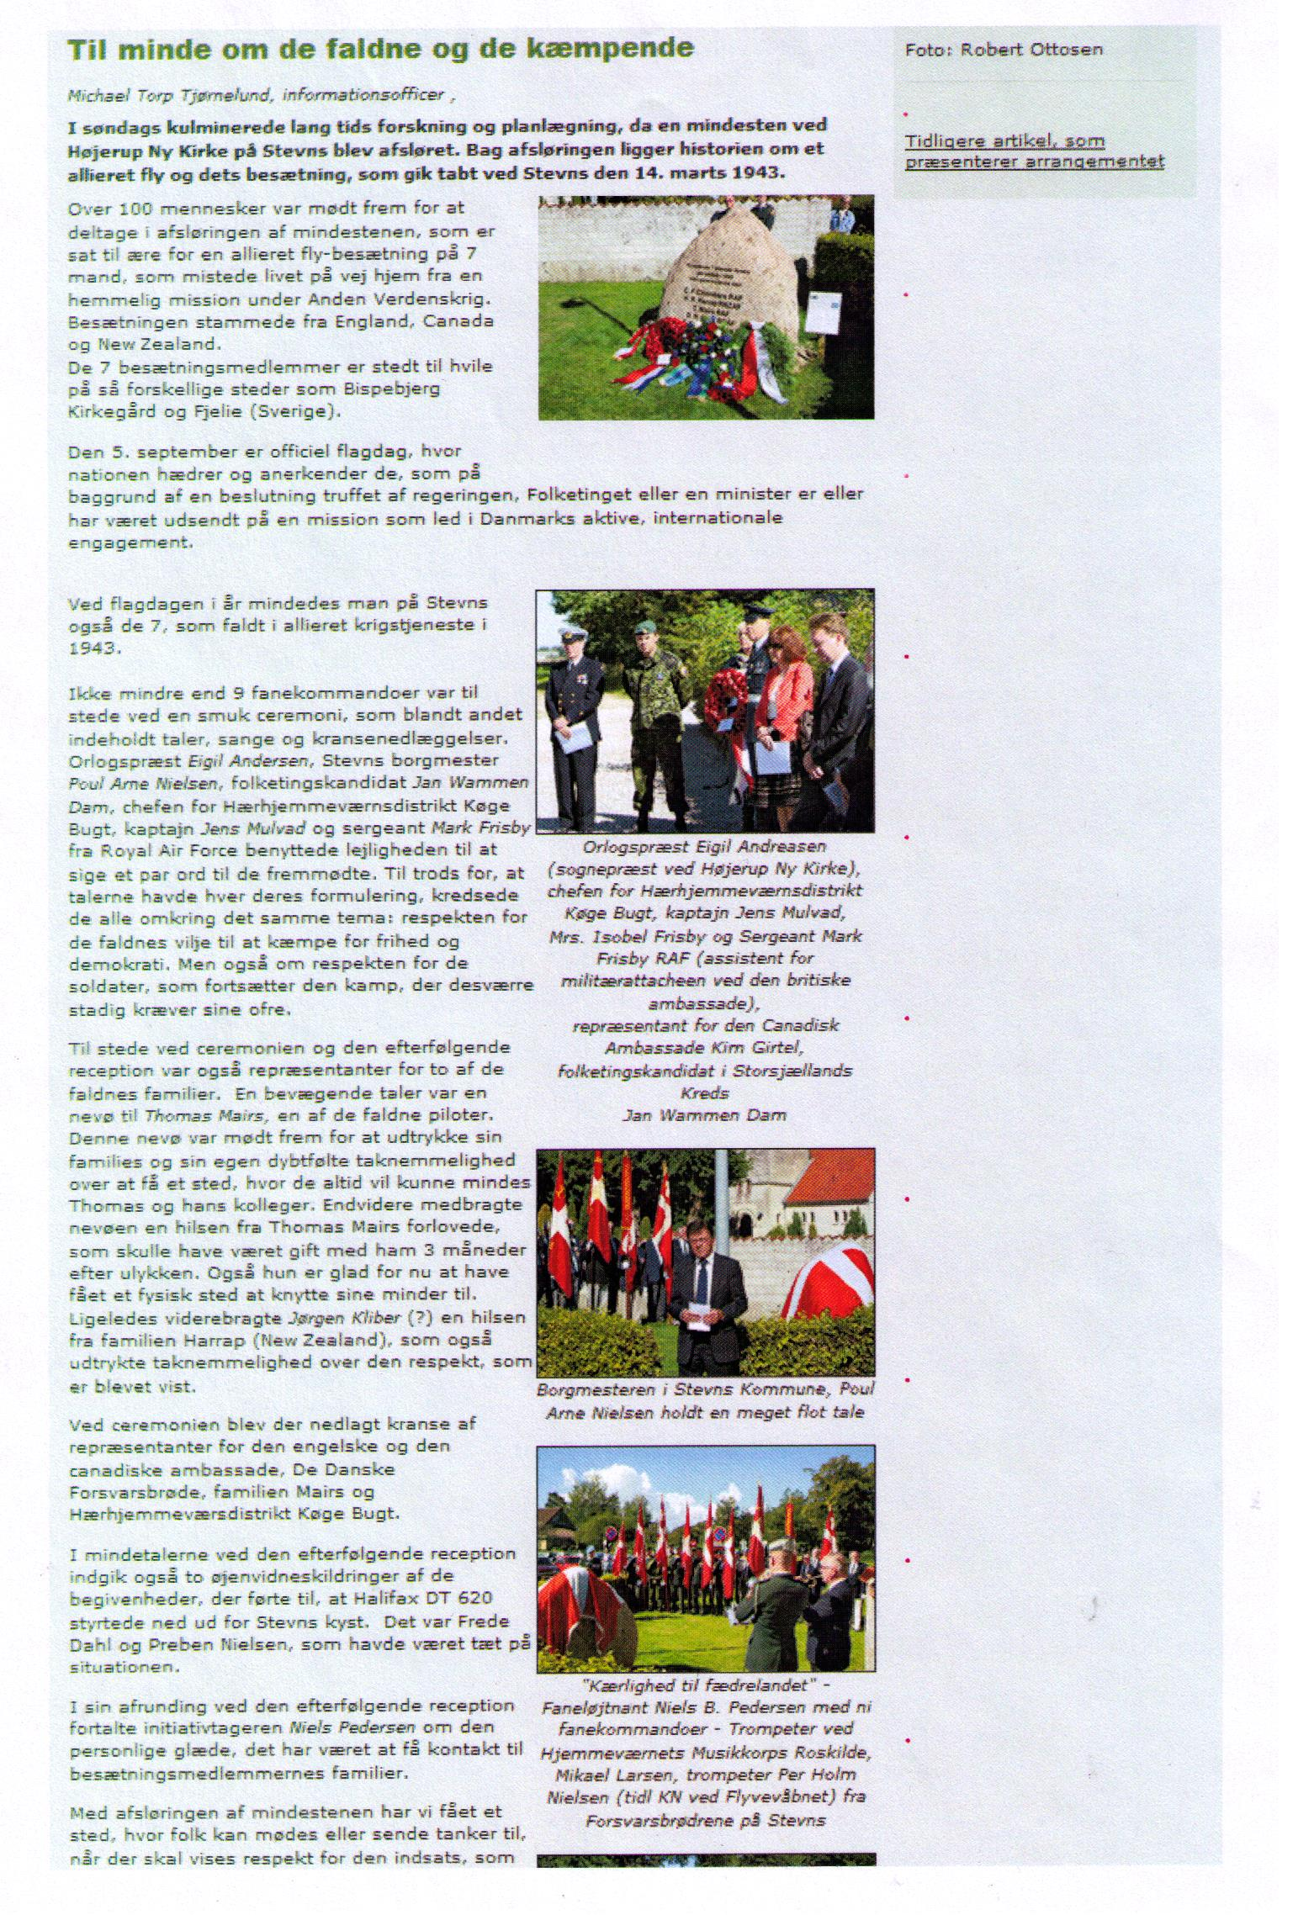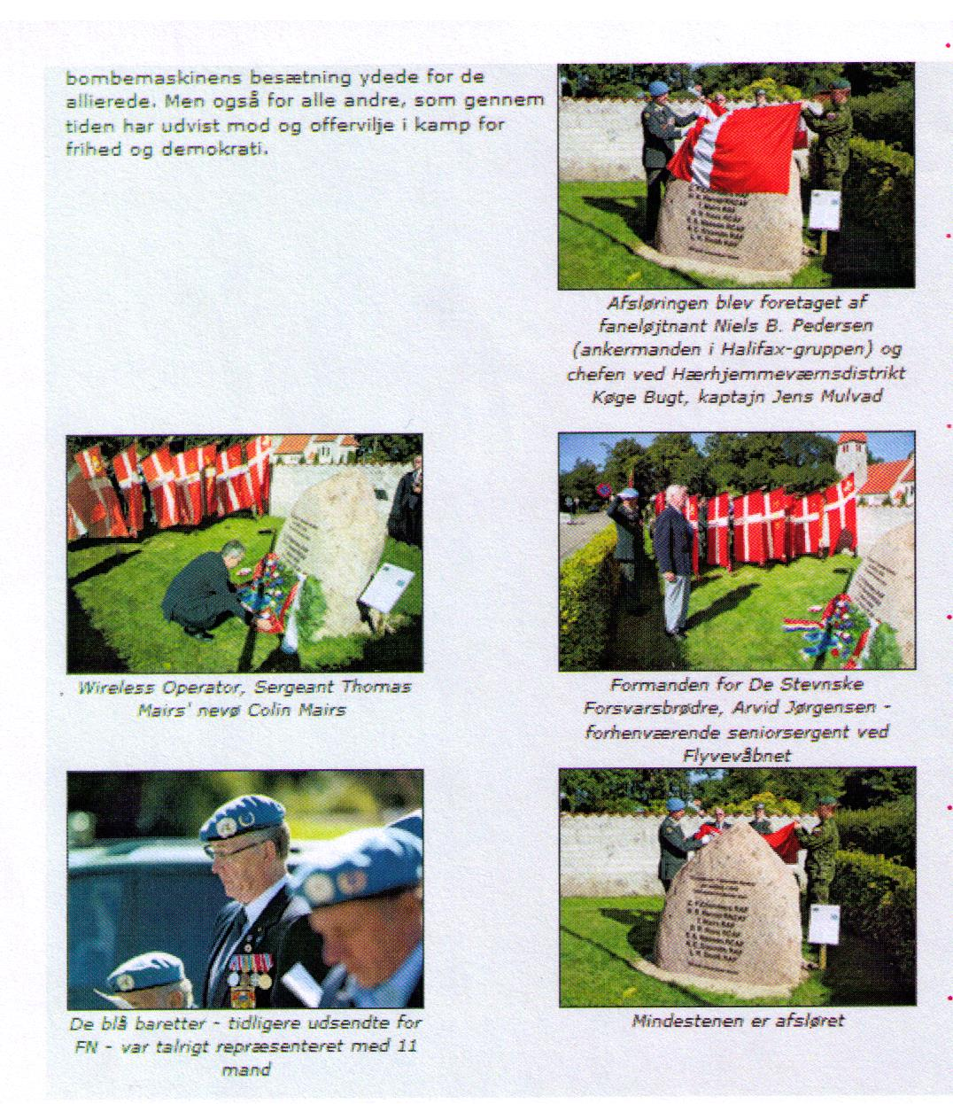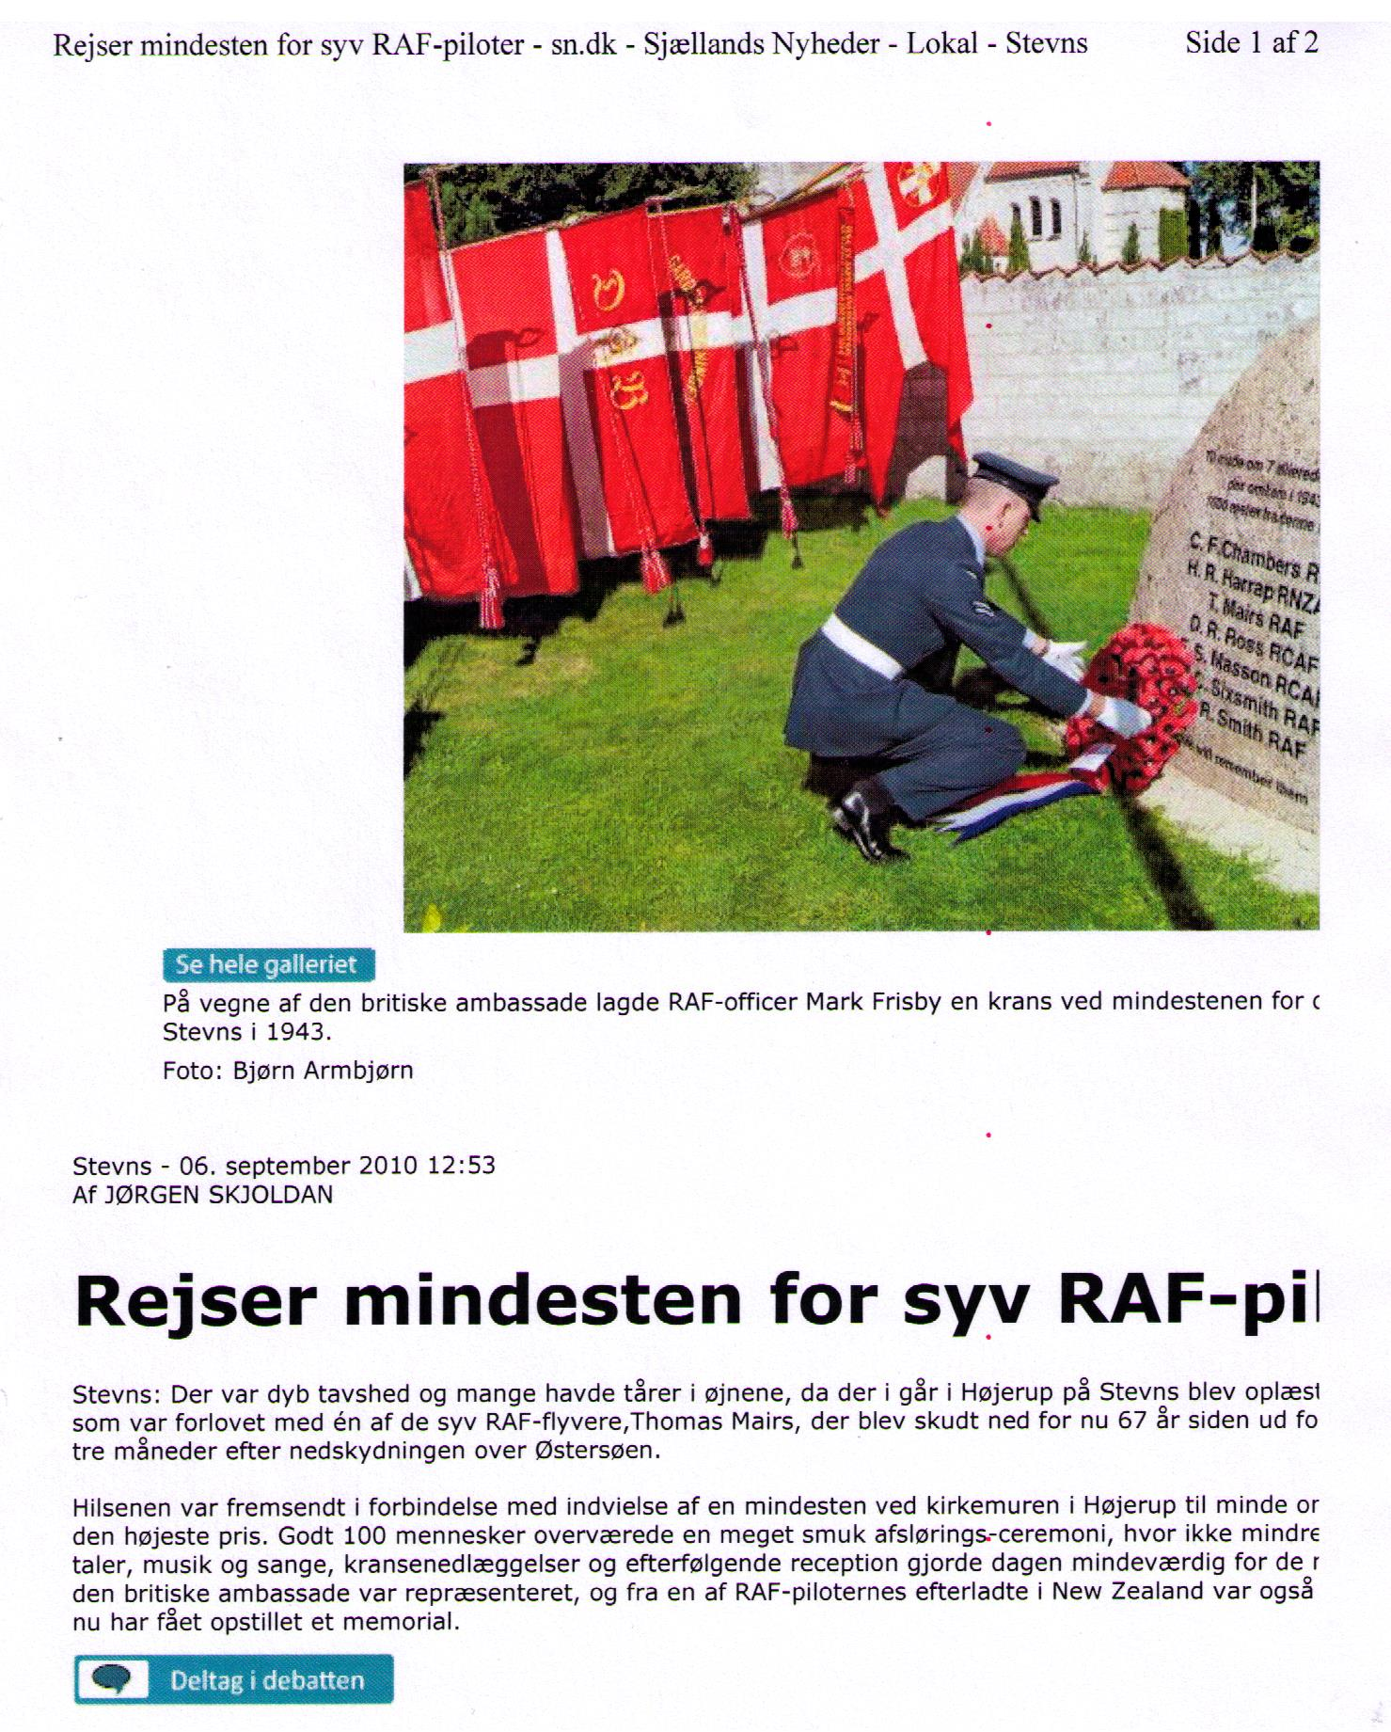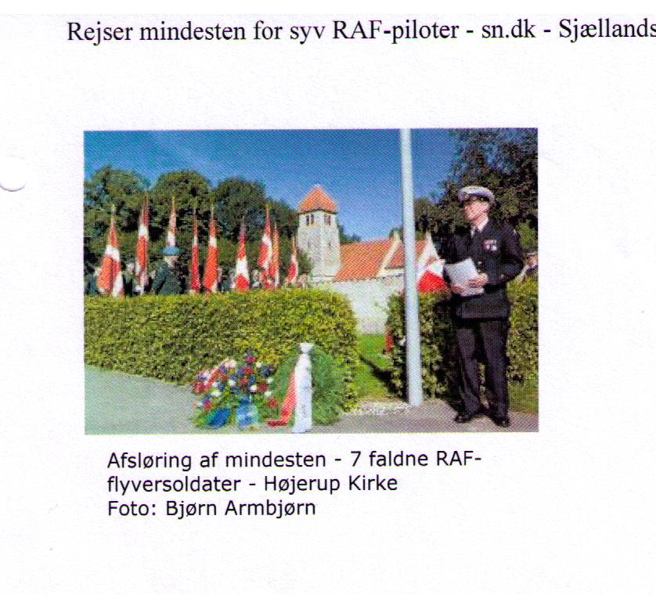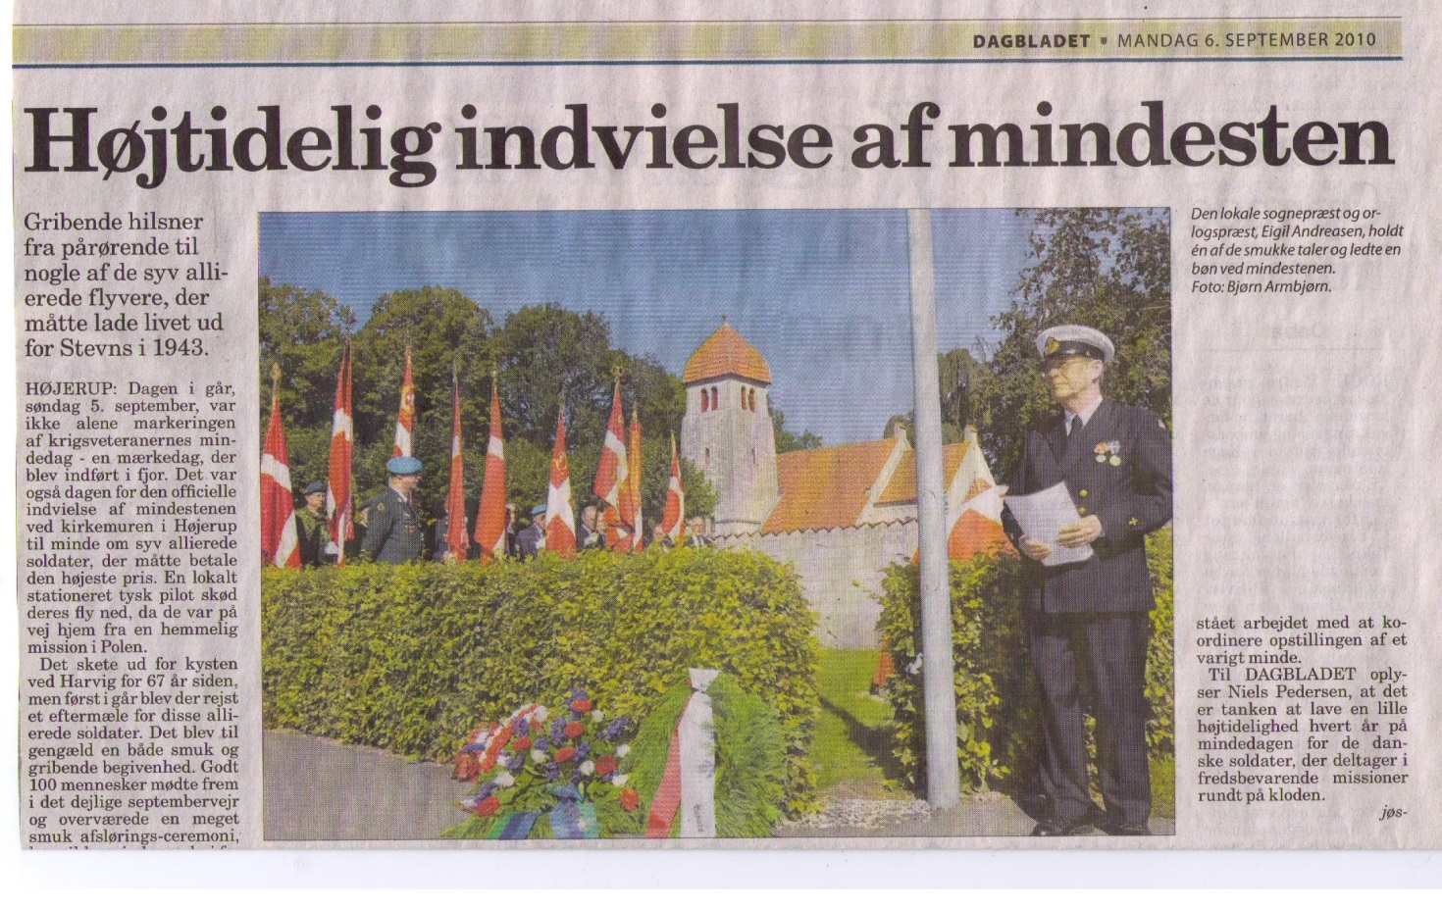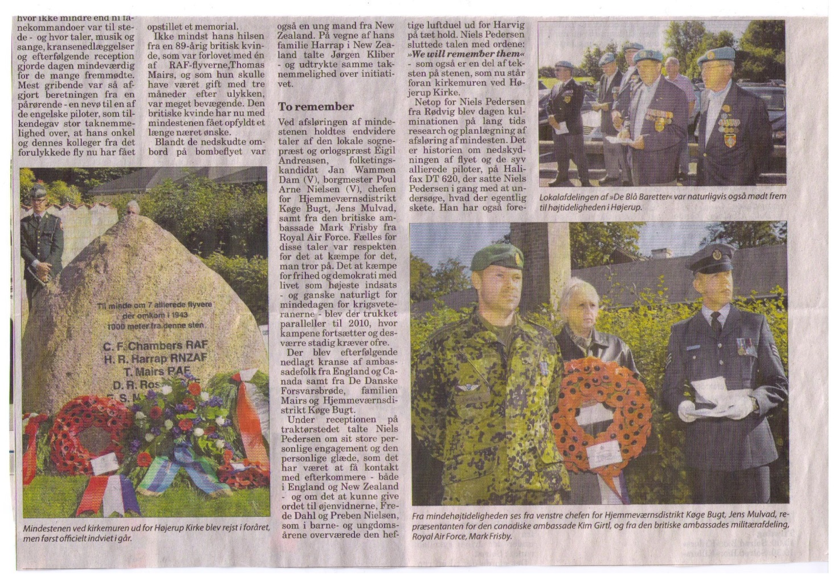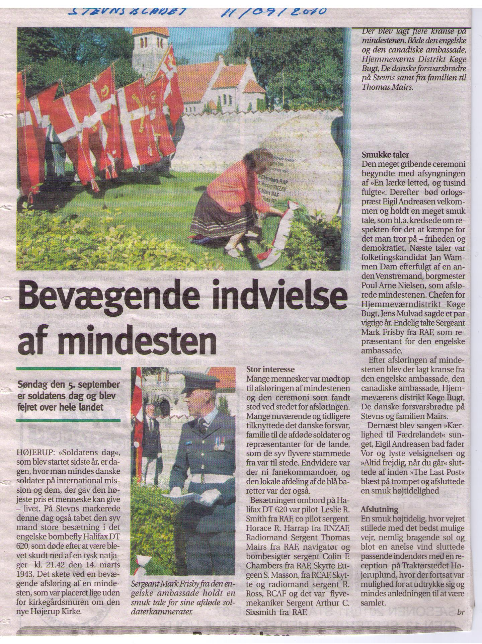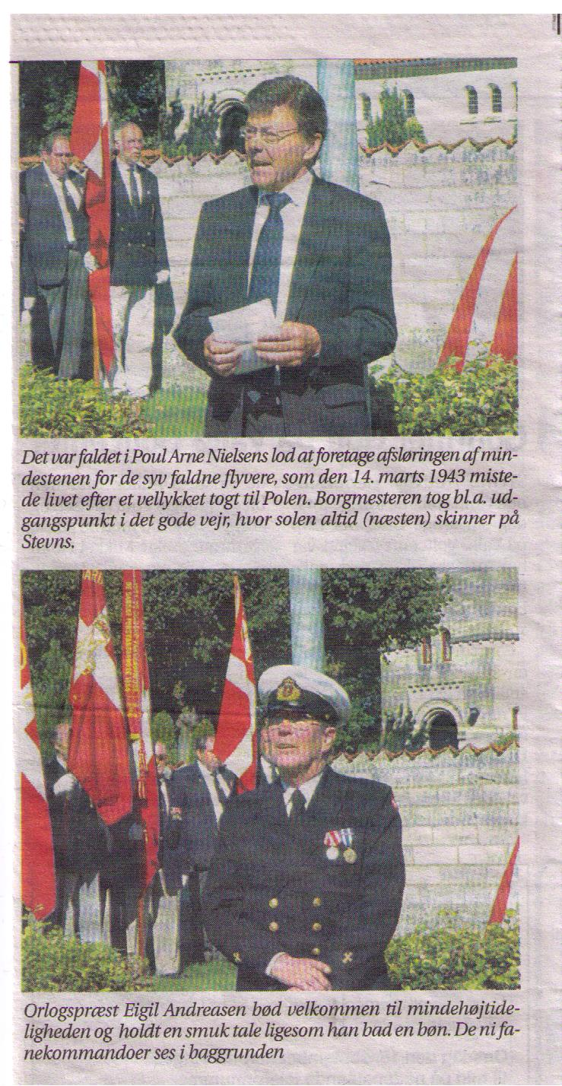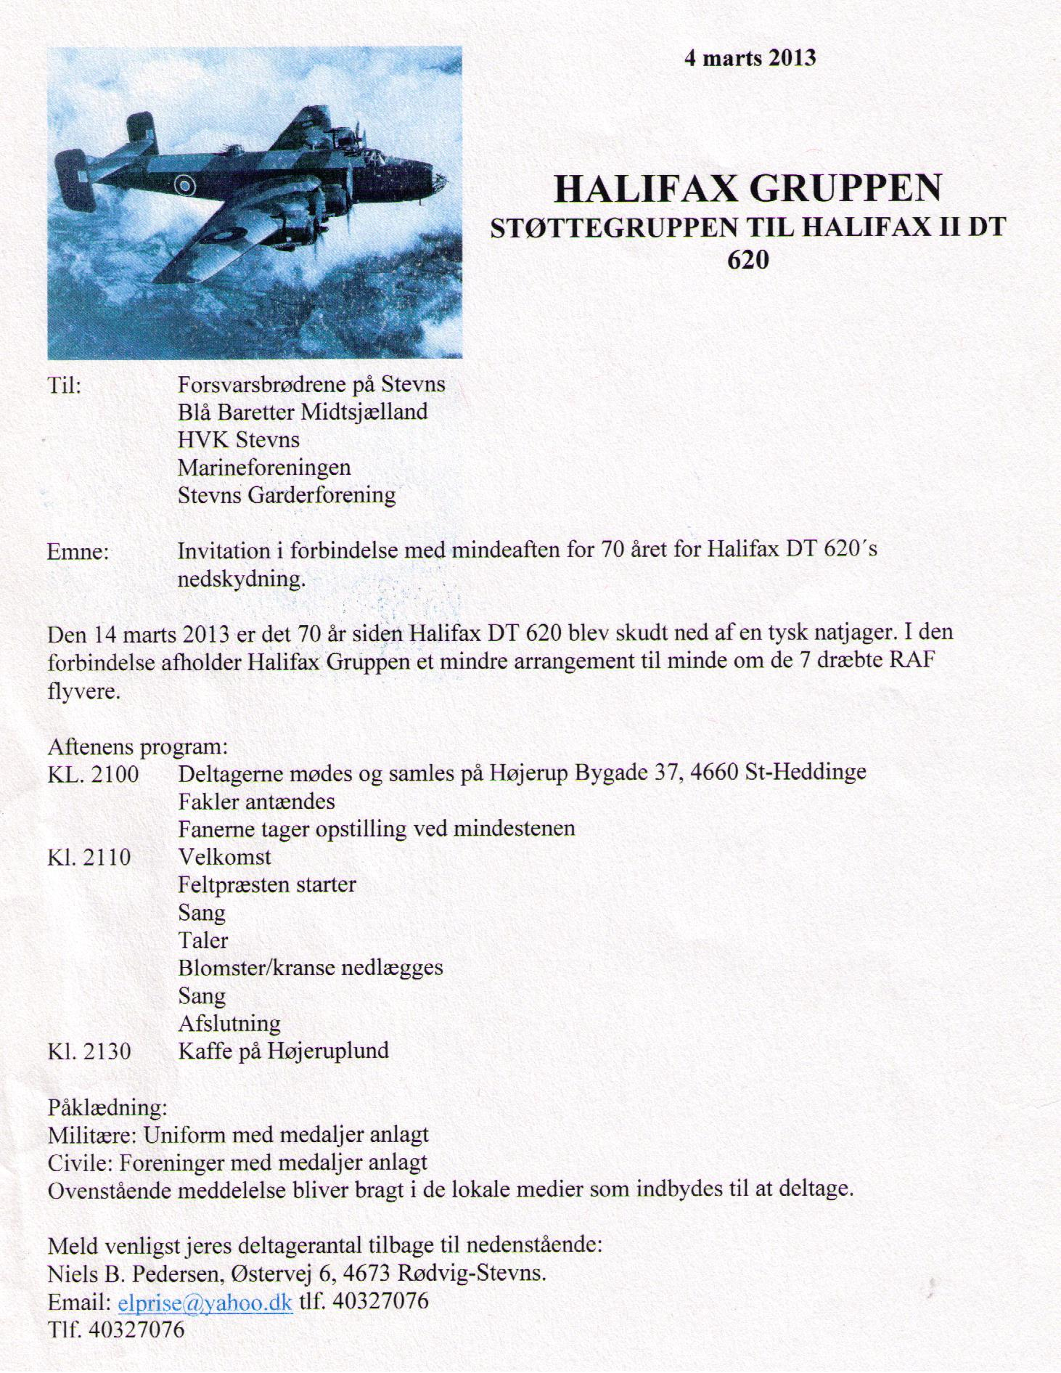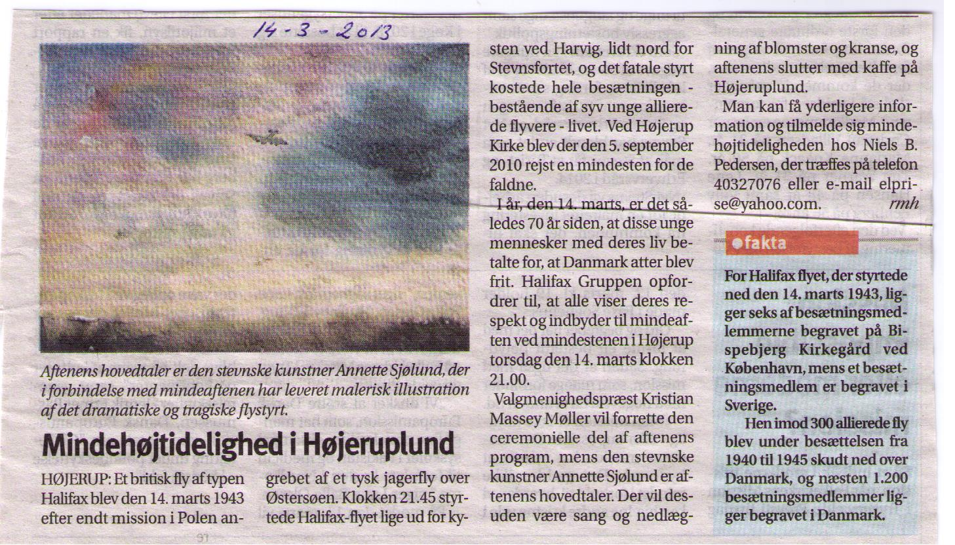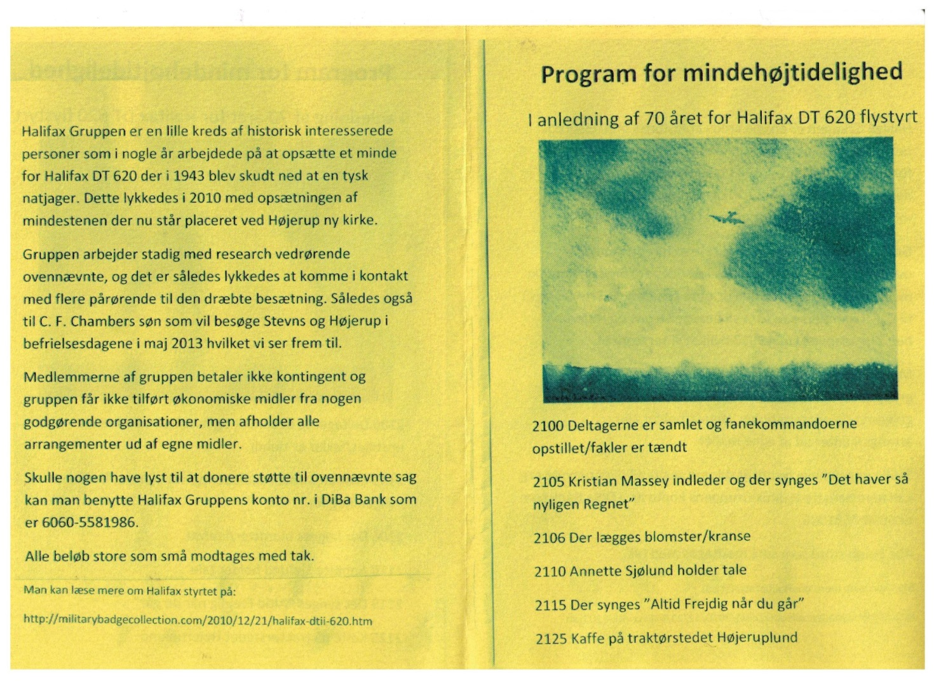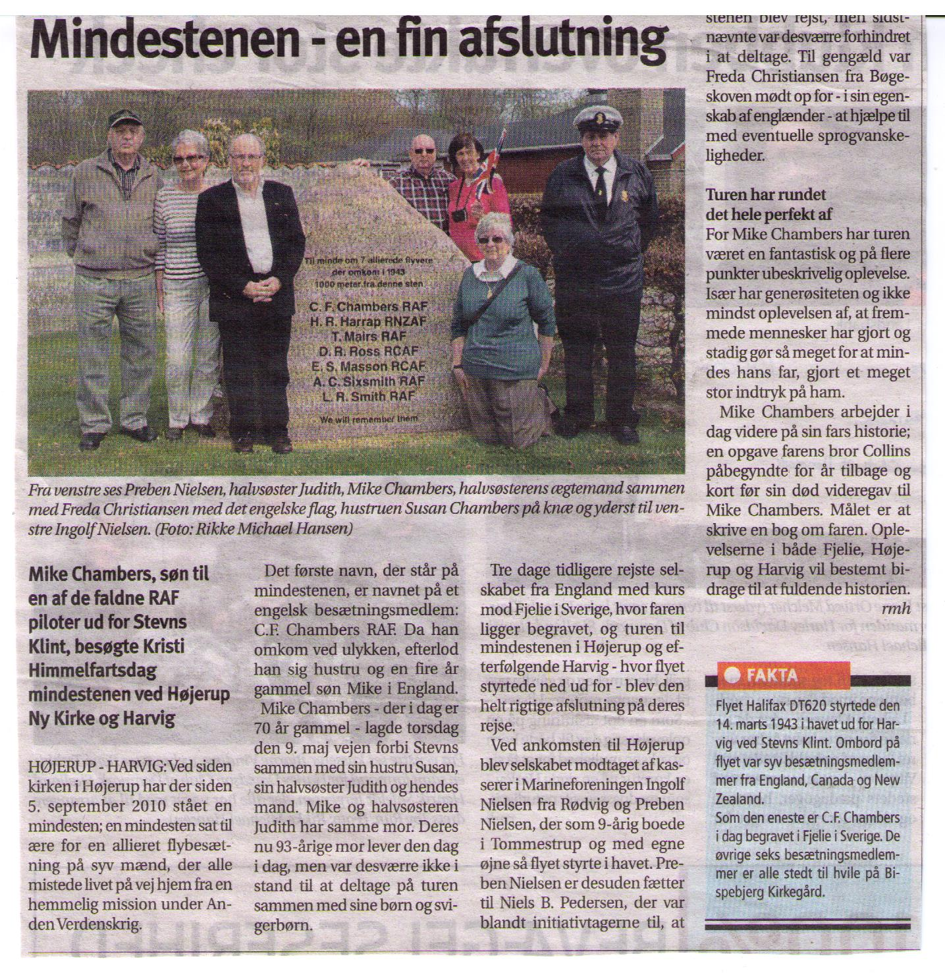0

